## Task 1- Creating and Renaming Files/Directories

Using mkdir and touch.

(mkdir is used to create directory/folders , touch is use to create files)

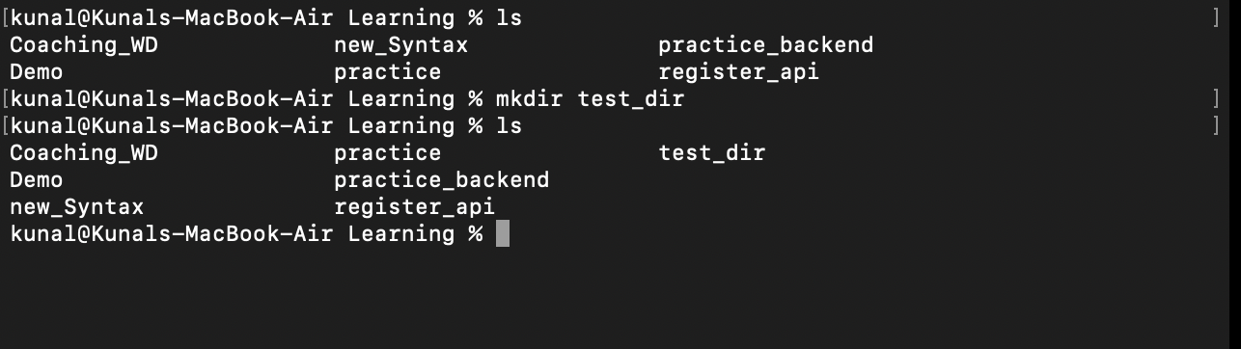

## Task 2- Viewing File Contents

Using cat, head and tail.

(cat displays the entire content of a file on the terminal.)

(head -n 5 :used to get first 5 lines of the content)

(tail -n 5 :is used for last 5 lines)

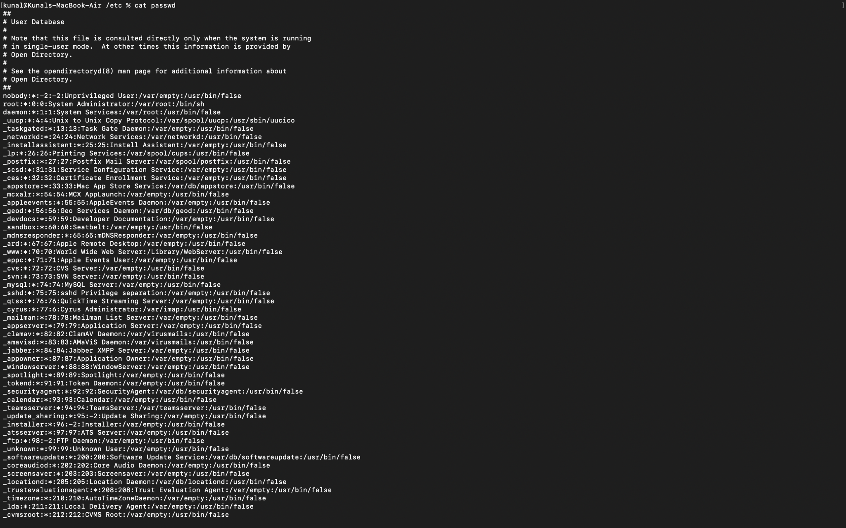

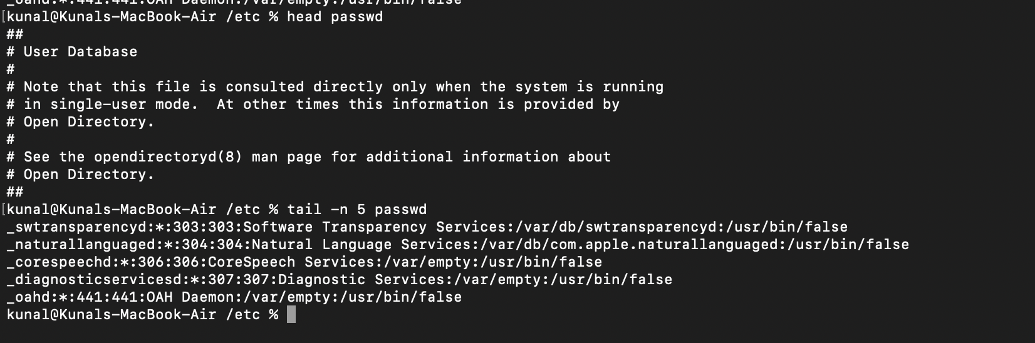

## Task 3- Searching for Patterns

Using grep.

(Searches for a specific pattern (text) in a file and prints matching lines.)

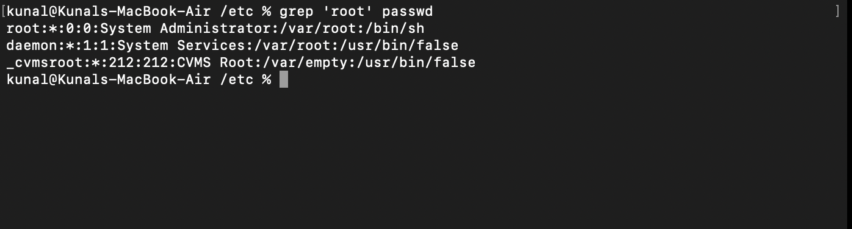

## Task 4- Zipping and Unzipping

Using zip and unzip.

(Compresses files into a **.zip** archive.)

(Extracts files from a **.zip** archive.)

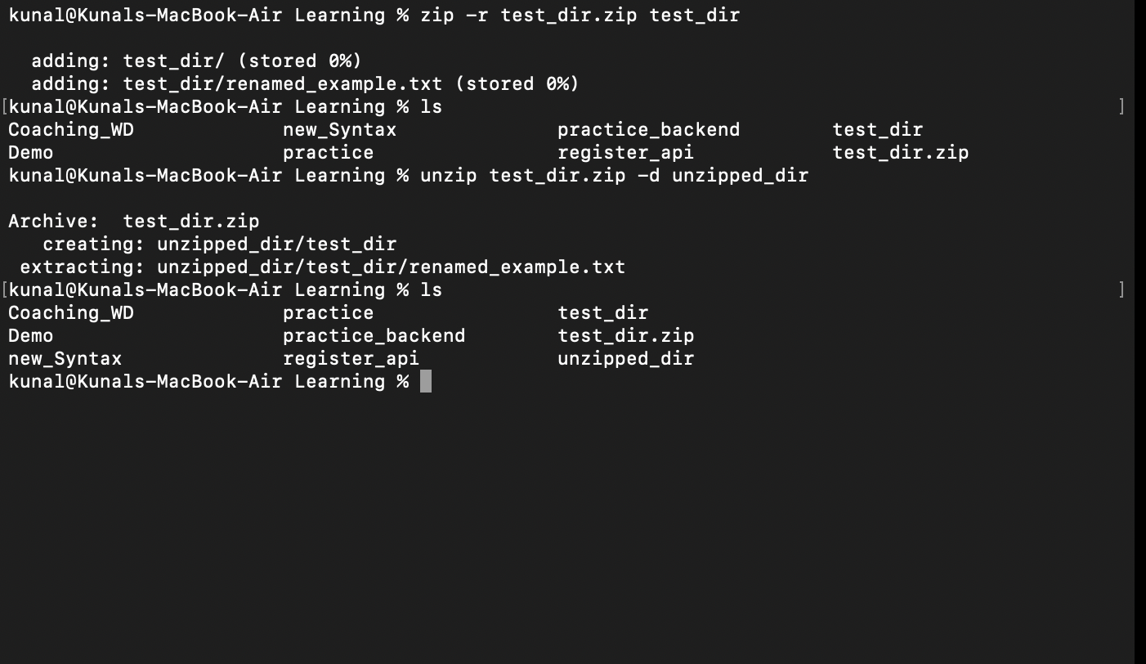

## Task 5- Downloading Files

Using wget.

Note- I am working on mac, so to use wget i need to first brew install wget to my system.

(Downloads a file from the specified URL to the current directory.)

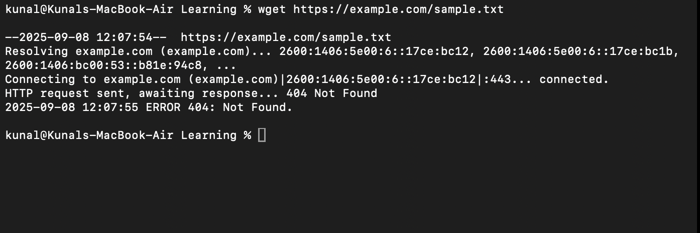

## Task 6- Changing Permissions

Using chmod.

(chmod 444 secure.txt :read-only for owner, group, and others)

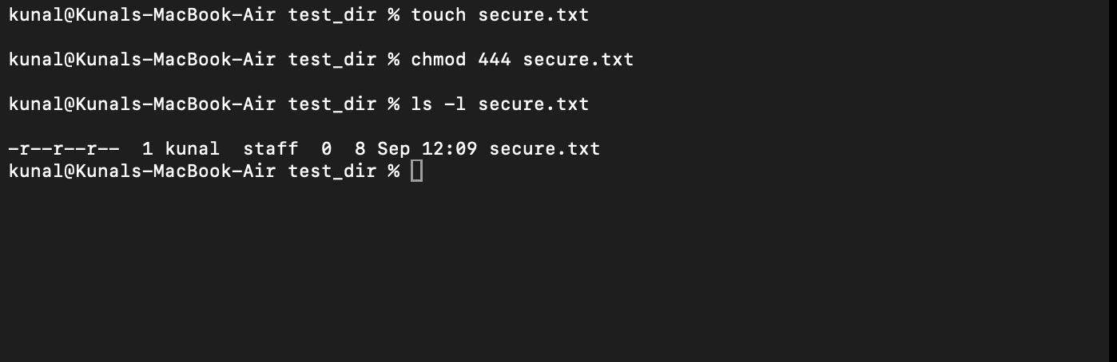

## 

## Task 7- Working with Environment Variables

Using export.

(Creates a new environment variable MY_VAR with the value "Hello, Linux!" for the current shell session.)

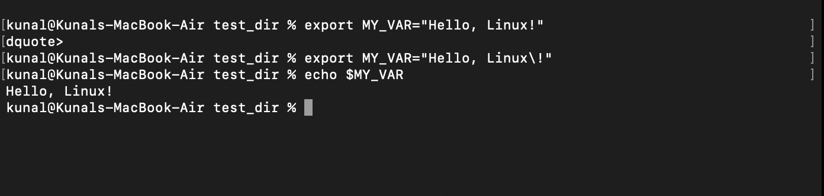

My github repo link : https://github.com/kunal592/Devops.git